A2 Physics

Unit 4
Fields and Further Mechanics
1 Momentum and Collisions
2 Force and Impulse
3 Circular Motion
4 Centripetal Force and Acceleration
5 Simple Harmonic Motion
6 SHM Graphs
7 SHM Time Periods
8 Resonance and Damping
9 Gravitational Fields
10 Gravitational Potential
11 Orbits and Escape Velocity
12 Electric Fields
13 Electric Potential
14 Fields Comparison
15 Capacitors
16 Charging and Discharging
17 Exponential Decay
18 Force on a Current Carrying Wire
19 Force on a Charged Particle
20 Magnetic Flux and Flux Linkage
21 Electromagnetic Induction
22 Transformers

Unit 4 | Momentum and Collisions
Lesson 1
Learning Outcomes | To be able to calculate momentum and know the units
Learning Outcomes | To be able to explain the difference between elastic and inelastic collisions
Learning Outcomes | To be able to find the velocity of an object after a collision or explosion | N. DWYER

Momentum (Also seen in GCSE Physics 2)
The momentum of an object is given by the equation: momentum = mass x velocity $p=\text{mv}$
Since it depends on the velocity and not speed, momentum is a vector quantity. If we assign a direction to be positive for example if → was positive, an object with negative velocity would be moving ←. It would also have a negative momentum.
Momentum is measured in kilogram metres per second, kg m/s or kg m s⁻¹

Conservation (Also seen in GCSE Physics 2)
In an isolated system (if no external forces are acting) the linear momentum is conserved.
We can say that: the total momentum before = the total momentum after
The total momentum before and after what? A collision or an explosion.

Collisions (Also seen in GCSE Physics 2)
There are two types of collisions; in both cases the momentum is conserved.
Elastic – kinetic energy in conserved, no energy is transferred to the surroundings
If a ball is dropped, hits the floor and bounces back to the same height it would be an elastic collision with the floor. The kinetic energy before the collision is the same as the kinetic energy after the collision.
Inelastic – kinetic energy is not conserved, energy is transferred to the surroundings
If a ball is dropped, hits the floor and bounces back to a lower height than released it would be an inelastic collision. The kinetic energy before the collision would be greater than the kinetic energy after the collision.
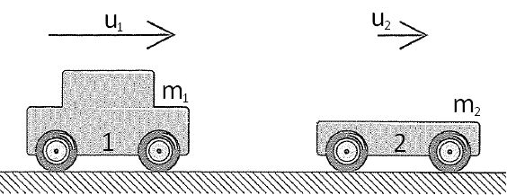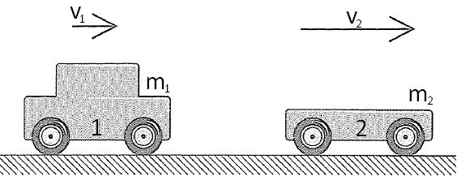
Before After
In the situation above, car 1 and car 2 travel to the right with initial velocities u₁ and u₂ respectively. Car 1 catches up to car 2 and they collide. After the collision the cars continue to move to the right but car 1 now travels at velocity v₁ and car 2 travels a velocity v₂. [→ is positive]
Since momentum is conserved the total momentum before the crash = the total momentum after the crash.
The total momentum before is the momentum of A + the momentum of B
The total momentum after is the new momentum of A + the new momentum of B
We can represent this with the equation: $m_{1}u_{1}+m_{2}u_{2}=m_{1}v_{1}+m_{2}v_{2}$

Explosions (Also seen in GCSE Physics 2)
We look at explosions in the same way as we look at collisions, the total momentum before is equal to the total momentum after. In explosions the total momentum before is zero. [→ is positive]
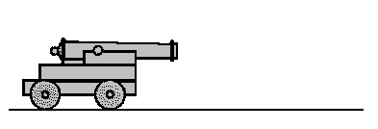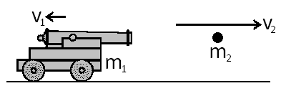
Before After
If we look at the example above we can see that the whole system is not moving, so the momentum before is zero. After the explosion the shell travels right with velocity v₂ and the cannon recoils with a velocity v₁.
The momentum of the system is given as: $m_{1}u_{1}+m_{2}u_{2}=m_{1}v_{1}+m_{2}v_{2}$
So the equation for this diagram would be: $0=m_{1}v_{1}+m_{2}v_{2}$
But remember, v₁ is negative so: $0=−m_{1}v_{1}+m_{2}v_{2}$ → $m_{1}v_{1}=m_{2}v_{2}$
Unit 4 | Force and Impulse
Lesson 2
Learning Outcomes | To be able to calculate force from change in momentum
Learning Outcomes | To be able to explain and calculate impulse
Learning Outcomes | To know the significance of the area under a force-time graph | N. DWYER

Force (Also seen in GCSE Physics 2)
If we start at F = ma we can derive an equation that links force and momentum.
$F=\text{ma}$ we can replace a in this equation with $a=\frac{(v−u)}{t}$ from Unit 2
$F=m\frac{(v−u)}{t}$ multiplying out makes the equation
$F=\frac{\text{mv}−\text{mu}}{t}$ or $F=\frac{Δ(\text{mv})}{Δt}$ where ∆ means ‘the change in’
This states that the force is a measure of change of momentum with respect to time. This is Newton’s Second Law of Motion:
The rate of change of an object’s linear momentum is directly proportional to the resultant external force. The change in the momentum takes place in the direction of the force.

If we have a trolley and we increase its velocity from rest to 3m/s in 10 seconds, we know that it takes a bigger force to do the same with a trolley that’s full of shopping. Ever tried turning a trolley around a corner when empty and then when full?
Force is measured in Newtons, N

Car Safety (Also seen in GCSE Physics 2)
Many of the safety features of a car rely on the above equation. Airbags, seatbelts and the crumple zone increase the time taken for the car and the people inside to stop moving. Increasing the time taken to change the momentum to zero reduces the force experienced.

Catching
An Egg: If we held our hand out and didn’t move it the egg would smash. The change in momentum happens in a short time, making the force large. If we cup the egg and move our hands down as we catch it we make it take longer to come to a complete stop. Increasing the time taken decreases the force and the egg remains intact.
Cricket Ball: If we didn’t move our hands it would hurt when the ball stopped in our hands. If we make it take longer to stop we reduce the force on our hands from the ball.

Impulse
$F=\frac{\text{mv}−\text{mu}}{t}$ multiply both sides by t → $\text{Ft}=\text{mv}−\text{mu}$
$F=\frac{Δ(\text{mv})}{Δt}$ multiply both sides by t → $FΔt=Δ(\text{mv})$
We now have an equation for impulse. Impulse is the product of the force and the time it is applied for.
An impulse causes a change in momentum.
Impulse is measured in Newton seconds, Ns

Since $FΔt=Δ(\text{mv})$, the same impulse (same force applied for the same amount of time) can be applied to a small mass to cause a large velocity or to a large mass to cause a small velocity
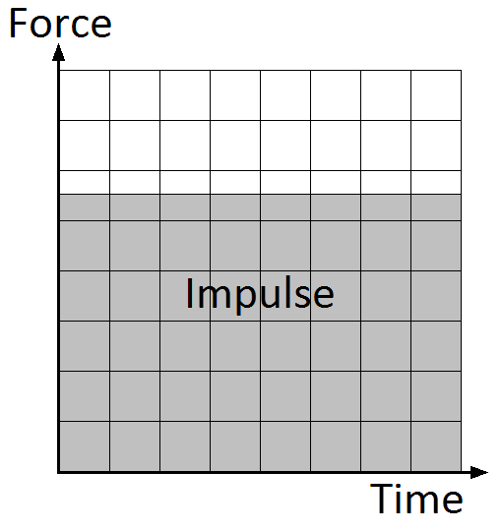
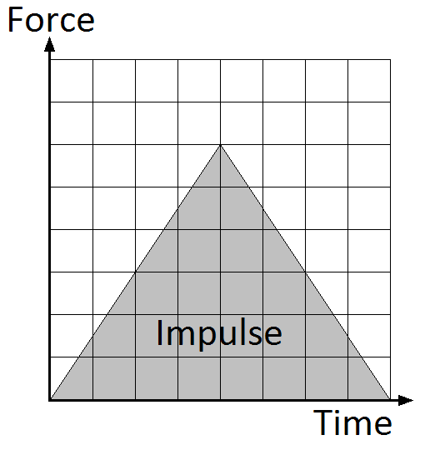
Ft = mv = mv

Force-Time Graphs
The impulse can be calculated from a force-time graph, it is the same as the area under the graph.
The area of the first graph is given by:
height x length = Force x time = Impulse

Unit 4 | Circular Motion
Lesson 3
Learning Outcomes | To be able to calculate the angular displacement of an object moving in a circle
Learning Outcomes | To be able to calculate the angular speed of an object moving in a circle
Learning Outcomes | To be able to calculate the speed of an object moving in a circle | N. DWYER
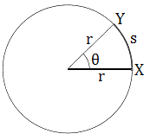
To the right is the path a car is taking as it moves in a circle of radius r.

Angular Displacement, θ
As the car travels from X to Y it has travelled a distance of s and has covered a section of the complete circle it will make. It has covered and angle of θ which is called the angular displacement.
$θ=\frac{\text{arc}}{\text{radius}}$ $θ=\frac{s}{r}$
Angular Displacement is measured in radians, rad

Radians
1 radian is the angle made when the arc of a circle is equal to the radius.
For a complete circle $θ=\frac{\text{arc}}{\text{radius}}$ → $θ=\frac{\text{circumference}}{\text{radius}}$ → $θ=\frac{2πr}{r}$ → $θ=2π$
A complete circle is 360° so 360° = 2π rad
1° = 0.017 rad 57.3° = 1 rad

Angular Speed, ω
Angular speed is the rate of change of angular displacement, or the angle that is covered every second.
$ω=\frac{θ}{t}$
Angular Speed is measured in radians per second, rad/s or rad s⁻¹

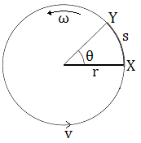
Frequency, f
Frequency is the number of complete circles that occur every second.
For one circle; $θ=2π$, if we substitute this into the equation above we get $ω=\frac{2π}{t}$
This equation says that the angular speed (angle made per second) is equal to one circle divided by the time taken to do it. Very similar to speed = distance/time
Since $f=\frac{1}{T}$ the above equation can be written as $ω=2πf$
Frequency is measures in Hertz, Hz

Speed, v
The velocity of the car is constantly changing because the direction is constantly changing. The speed however, is constant and can be calculated.
$v=\frac{s}{t}$ If we rearrange the top equation we can get $rθ=s$, the speed then becomes
$v=\frac{rθ}{t}$ Now if we rearrange the second equation we get $ωt=θ$, the equation becomes
$v=\frac{rωt}{t}$ Cancel the t’s and we finally arrive at our equation for the speed.
$$v=rω$$
Speed is measured in metres per second, m/s or m s⁻¹
Unit 4 | Centripetal Force and Acceleration
Lesson 4
Learning Outcomes | To be able to calculate the centripetal acceleration of an object moving in a circle
Learning Outcomes | To be able to calculate the centripetal force that keeps an object moving in a circle
Learning Outcomes | To be able to explain why the centrifugal force does not exist | N. DWYER

Moving in a Circle (Also seen in GCSE Physics 3)
For an object to continue to move in a circle a force is needed that acts on the object towards the centre of the circle. This is called the centripetal force and is provided by a number of things:
For a satellite orbiting the Earth it is provided by gravitational attraction.
For a car driving around a roundabout it is provided by the friction between the wheels and the road.
For a ball on a string being swung in a circle it is provided by the tension in the string.
Centripetal force acts from the body to the centre of a circle
Since F=ma the object must accelerate in the same direction as the resultant force. The object is constantly changing its direction towards the centre of the circle.
Centripetal acceleration has direction from the body to the centre of the circle

Centrifugal Force
Some people thought that an object moving in a circle would experience the centripetal force acting from the object towards the centre of the circle and the centrifugal force acting from the object away from the centre of the circle.
They thought this because if you sit on a roundabout as it spins it feels like you are being thrown off backwards.
If someone was watching from the side they would see you try and move in a straight line but be pulled in a circle by the roundabout.
The centrifugal force does not exist in these situations.
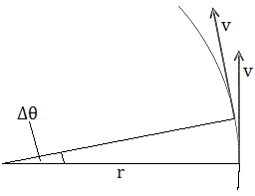

Centripetal Acceleration
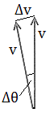
The centripetal acceleration of an object can be derived if we look at the situation to the right. An object of speed v makes an angular displacement of ∆θ in time ∆t.
$$a=\frac{Δv}{Δt}$$
If we look at the triangle at the far right we can use $θ=\frac{s}{r}$ when θ is small. This becomes: $Δθ=\frac{Δv}{v}$
We can rearrange this to give: $vΔθ=Δv$
Acceleration is given by$a=\frac{Δv}{Δt}$ substitute the above equation into this one
$a=\frac{vΔθ}{Δt}$ this is the same as $a=v\frac{Δθ}{Δt}$
In lesson 3 (Circular Motion) we established that$ω=\frac{Δθ}{Δt}$, substitute this into the equation above
$a=vω$
If we use $v=rω$we can derive two more equations for acceleration
$a=vω$ $a={rω}^{2}$ $a=\frac{v^{2}}{r}$
Centripetal Acceleration is measured in metres per second squared, m/s² or m s⁻²

Centripetal Force
We can derive three equations for the centripetal force by using $F=\text{ma}$and the three equations of acceleration from above.
$F=\text{mv}ω$ $F=\text{mr}ω^{2}$ $F=m\frac{v^{2}}{r}$
Centripetal Force is measured in Newtons, N
Unit 4 | Simple Harmonic Motion
Lesson 5
Learning Outcomes | To know what simple harmonic motion is
Learning Outcomes | To be able to describe the acceleration of an SHM system
Learning Outcomes | To be able to calculate the displacement, velocity and acceleration of an SHM system | N. DWYER

Oscillations
In each of the cases below there is something that is oscillating, it vibrates back and forth or up and down.
Each of these systems is demonstrating Simple Harmonic Motion (SHM).
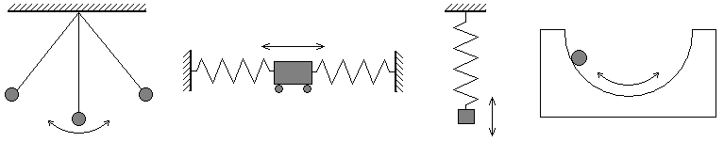

SHM Characteristics
The equilibrium point is where the object comes to rest, in the simple pendulum it at its lowest point.
If we displace the object by a displacement of x there will be a force that brings the object back to the equilibrium point. We call this the restoring force and it always acts in the opposite direction to the displacement.
We can represent this as: $F∝−x$
Since $F=\text{ma}$ we can also write: $a∝−x$

For an object to be moving with simple harmonic motion, its acceleration must satisfy two conditions:
*The acceleration is proportional to the displacement
*The acceleration is in the opposite direction to the displacement (towards the equilibrium point)
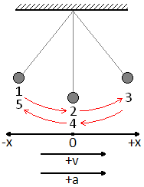

Equations
The following equations are true for all SHM systems but let us use the simple pendulum when thinking about them.
The pendulum bob is displaced in the negative direction when at point 1, it is released and swings through point 2 at its maximum speed until it reaches point 3 where it comes to a complete stop. It then swings to the negative direction, reaches a maximum speed at 4 and completes a full cycle when it stops at 5.

Displacement, x
The displacement of the bob after a time t is given by the equation: $x=A\text{cos}2π\text{ft}$ (CALCS IN RAD)
Since $f=\frac{1}{T}$ the equation can become: $x=A\text{cos}2π\frac{1}{T}t$ → $x=A\text{cos}2π\frac{t}{T}$
(where t is the time into the cycle and T is the time for one complete cycle)
The maximum displacement is called the amplitude, A. $x=A$ ← MAXIMUM

Velocity, v
The velocity of the bob at a displacement of x is given by the equation: $v=±2πf\sqrt{A^{2}−x^{2}}$
The maximum velocity occurs in the middle of the swing (2 and 4) when displacement is zero (x = 0)
$v=±2πf\sqrt{A^{2}−x^{2}}$ → $v=±2πf\sqrt{A^{2}−0^{2}}$ → $v=±2πf\sqrt{A^{2}}$ → $v=±2π\text{fA}$ ← MAXIMUM

Acceleration, a
The acceleration of the bob at a displacement of x is given by the equation: $a=−(2πf)^{2}x$
As discussed before the acceleration acts in the opposite direction to the displacement.
The maximum acceleration occurs at the ends of the swing (1, 3 and 5) when the displacement is equal to the amplitude (x = A).
$a=−(2πf)^{2}x$ → $a=−(2πf)^{2}A$ ← MAXIMUM
Unit 4 | SHM Graphs
Lesson 6
Learning Outcomes | To be able to sketch the graphs of displacement, velocity and acceleration for a simple pendulum
Learning Outcomes | To be know what the gradients represent
Learning Outcomes | To be able to explain the energy in a full cycle and sketch the graph | N. DWYER

Pendulum
Consider the simple pendulum drawn below. When released from A the bob accelerates and moves to the centre point. When it reached B it has reached a maximum velocity in the positive direction and then begins to slow down. At C it has stopped completely so the velocity is zero, it is at a maximum displacement in the positive and accelerates in the negative direction. At D it is back to the centre point and moves at maximum velocity in the negative direction. By E the velocity has dropped to zero, maximum negative displacement and a massive acceleration as it changes direction.
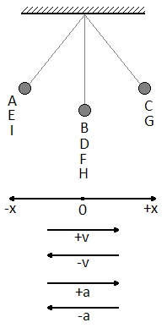
This repeats as the pendulum swings through F, G, H and back to I.
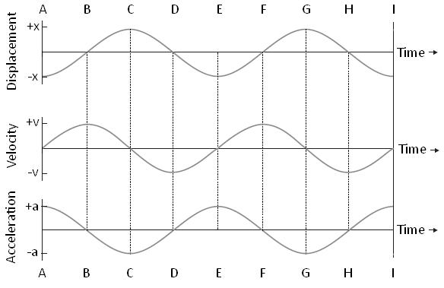
Below are the graphs that represent this:

Gradients
Since $v=\frac{Δs}{Δt}$the gradient of the displacement graph gives us velocity. At C the gradient is zero and we can see that the velocity is zero.
Also since $a=\frac{Δv}{Δt}$the gradient of the velocity graph gives us acceleration. At C the gradient is a maximum in the negative direction and we can see that the acceleration is a maximum in the negative direction.

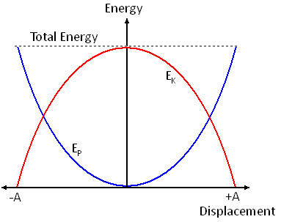
Energy
In all simple harmonic motion systems there is a conversion between kinetic energy and potential energy. The total energy of the system remains constant. (This is only true for isolated systems)
For a simple pendulum there is a transformation between kinetic energy and gravitational potential energy.
At its lowest point it has minimum gravitational and maximum kinetic, at its highest point (when displacement is a maximum) it has no kinetic but a maximum gravitational. This is shown in the graph.
For a mass on a spring there is a transformation between kinetic energy, gravitational potential energy and the energy stored in the spring (elastic potential). At the top there is maximum elastic and gravitational but minimum kinetic. In the middle there is maximum kinetic, minimum elastic but it still has some gravitational. At its lowest point it has no kinetic, minimum gravitational but maximum elastic.
Unit 4 | SHM Time Periods
Lesson 7
Learning Outcomes | To be able to calculate the time period of a simple pendulum
Learning Outcomes | To be able to calculate the time period of a mass on a spring
Learning Outcomes | To be able to describe the experiment to find g | N. DWYER

The Simple Pendulum
In the diagram we can see that the restoring force of the pendulum is: $F=−\text{mg}\text{sin}θ$
When θ is less than 10° (in radians) $\text{sin}θ≈θ=\frac{x}{l}$so the equation can become: $F=−\text{mg}\frac{x}{l}$
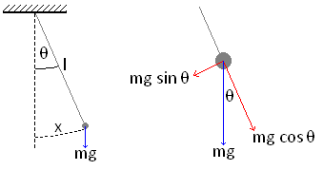
Since both $F=\text{ma}$and $a=−(2πf)^{2}x$(for SHM) the equation now becomes: $−\text{mg}\frac{x}{l}=−m(2πf)^{2}x$
This simplifies to: $\frac{g}{l}=(2πf)^{2}$
Rearranging for f gives us $f=\frac{1}{2π}\sqrt{\frac{g}{l}}$
And since $f=\frac{1}{T}$ then: $T=2π\sqrt{\frac{l}{g}}$
Time is measured in seconds, s

Mass on a Spring
When a spring with spring constant k and length l has a mass m attached to the bottom it extends by an extension e, this is called the static extension and is the new equilibrium point. The tension in the spring is balanced by the weight. We can represent this as: $T=\text{ke}=\text{mg}$
If the mass is pulled down by a displacement x and released it will undergo SHM.
The net upwards force will be: $F=−(k(e+x)−\text{mg})$
This can be multiplied out to become: $F=−(\text{ke}+\text{kx}−\text{mg})$
Since $\text{ke}=\text{mg}$ this can become: $F=−(\text{mg}+\text{kx}−\text{mg})$
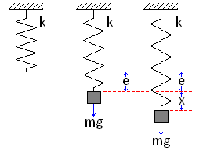
It simplify to: $F=−\text{kx}$
Since both $F=\text{ma}$and $a=−(2πf)^{2}x$(for SHM) the equation now becomes: $−\text{kx}=−m(2πf)^{2}x$
This simplifies to: $\frac{k}{m}=(2πf)^{2}$
Rearranging for f gives us: $f=\frac{1}{2π}\sqrt{\frac{k}{m}}$
And since $f=\frac{1}{T}$ the equation becomes: $T=2π\sqrt{\frac{m}{k}}$
Time is measured in seconds, s

Finding g
We can find the value of the gravitational field strength, g, on Earth by carrying out the following experiment.
Set up a simple pendulum of length l and measure the time for one oscillation.
If we measure the time taken for 20 oscillations and divide it by 20 we reduce the percentage human error of the reading and make our experiment more accurate.
If we look at the equation $T=2π\sqrt{\frac{l}{g}}$ and rearrange it to become: $T^{2}=\frac{4π^{2}}{g}l$, by plotting a graph of T² against l we can find the value of g from the gradient which will be = $\frac{4π^{2}}{g}$.
Unit 4 | Resonance and Damping
Lesson 8
Learning Outcomes | To know what free and forced vibration are and the phase difference between the driver and driven
Learning Outcomes | To know what resonance is and how it is reached
Learning Outcomes | To know what light, heavy and critical damping are and their affects on resonance | N. DWYER

Free Vibration
Free vibration is where a system is given an initial displacement and then allowed to vibrate/oscillate freely. The system will oscillate at a set frequency called the natural frequency, f₀. We have seen from the last lesson that the time period for a pendulum only depends on the length and gravitational field strength whilst the time period of a mass and spring only depends on the mass and the spring constant. These factors govern the natural frequency of a system.

Forced Vibration
Forced vibration is where a driving force is continuously applied to make the system vibrate/oscillate. The thing that provides the driving force will be moving at a certain frequency. We call this the driving frequency.

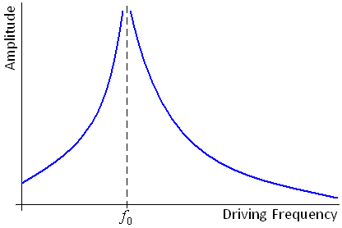
Resonance
If I hold one end of a slinky and let the other oscillate freely we have a free vibration system. If I move my hand up and down I force the slinky to vibrate. The frequency of my hand is the driving frequency.
When the driving frequency is lower than the natural frequency the oscillations have a low amplitude
When the driving frequency is the same as the natural frequency the amplitude increases massively, maybe even exponentially.
When the driving frequency is higher than the natural frequency the amplitude of the oscillations decreases again.

Phase Difference between driver and driven
When the driving force begins to oscillate the driven object the phase difference is 0.
When resonance is achieved the phase difference between them is π.
When the driving frequency increases beyond the natural frequency the phase difference increases to π/2.

Damping
Damping forces oppose the motion of the oscillating body, they slow or stop simple harmonic motion from occurring. Damping forces act in the opposite direction to the velocity.
Galileo made an important observation while watching lamps swing in Pisa cathedral. He noticed that the swinging gradually died away but the time taken for each swing stayed roughly the same. The swing of the lamp was being damped by air resistance.
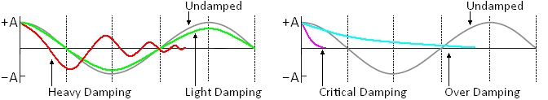
Light damping slowly reduces the amplitude of the oscillations, but keeps the time period almost constant.
Heavy damping allows the body to oscillate but brings it quickly to rest.
Critical damping brings the body back to the equilibrium point very quickly with out oscillation.
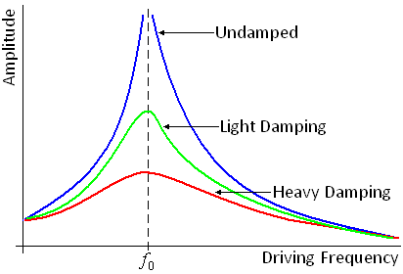
Over damping also prevent oscillation but makes the body take a longer time to reach equilibrium.

Damping and Resonance
Damping reduces the size of the oscillations at resonance. There is still a maximum amplitude reached but it is much lower than when the system is undamped. We say that damping reduces the sharpness of resonance. This becomes clearer if we look at the graph on the right.
It shows the amplitude of oscillation against frequency for different levels of damping.
Unit 4 | Gravitational Fields
Lesson 9
Learning Outcomes | To be able to calculate the force of gravity between two masses
Learning Outcomes | To be able to explain what gravitational field strength is
Learning Outcomes | To be able to calculate the gravitational field strength at a distance r from the centre | N. DWYER

Newton’s Law of Gravitation (Gravity) (Also seen in GCSE Physics 3)
Gravity is an attractive force that acts between all masses. It is the masses themselves that cause the force to exist. The force that acts between two masses, m₁ and m₂, whose centres are separated by a distance of r is given by:
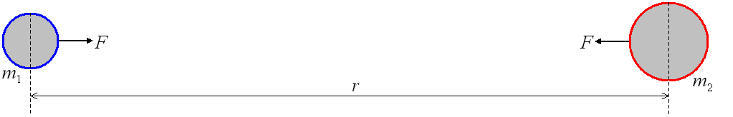
$$F∝\frac{m_{1}m_{2}}{r^{2}}$$
This was tested experimentally in a lab using large lead spheres and was refined to become:
$$F=−\frac{{\text{Gm}}_{1}m_{2}}{r^{2}}$$
G is the Gravitational Constant, G = 6.67 x 10⁻¹¹ N m² kg⁻²
When one of the masses is of planetary size, M, the force between it and a test mass, m, whose centres are separated by a distance of r is given by:
$$F=−\frac{\text{GMm}}{r^{2}}$$
The minus sign means that the force is attractive, the force is in the opposite direction to the distance from the mass (displacement). This will become clearer when we look at the electric force.
Negative = Attractive
Positive = Repulsive
Force is measured in Newtons, N

Gravitational Fields
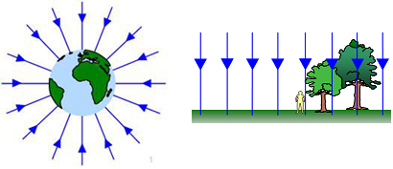
A gravitational field is the area around a mass where any other mass will experience a force. We can model a field with field lines or lines of force.
Radial Fields
The field lines end at the centre of a mass and tail back to infinity. We can see that they become more spread out the further from the mass we go.
Uniform Fields
The field lines are parallel in a uniform field. At the surface of the Earth we can assume the field lines are parallel, even thou they are not.

Gravitational Field Strength, g
We can think of gravitational field strength as the concentration of the field lines at that point. We can see from the diagrams above that the field strength is constant in a uniform field but drops quickly as we move further out in a radial field.
The gravitational field strength at a point is a vector quantity and is defined as:
The force per unit mass acting on a small mass placed at that point in the field.
We can represent this with the equation: $g=\frac{F}{m}$
If we use our equation for the gravitational force at a distance r and substitute this in for F we get:
$g=−\frac{\text{GMm}}{r^{2}m}$ which simplifies to: $g=−\frac{\text{GM}}{r^{2}}$
Gravitational Field Strength is measured in Newtons per kilogram, N kg⁻¹
Unit 4 | Gravitational Potential
Lesson 10
Learning Outcomes | To be able to explain what gravitational potential is and be able to calculate it
Learning Outcomes | To know how gravitational potential is linked to potential energy and be able to calculate it
Learning Outcomes | To be able to sketch graphs of potential and field strength over distance from surface | N. DWYER

Gravitational Potential, V
The gravitational potential at a point r from a planet or mass is defined as:
The work done per unit mass against the field to move a point mass from infinity to that point
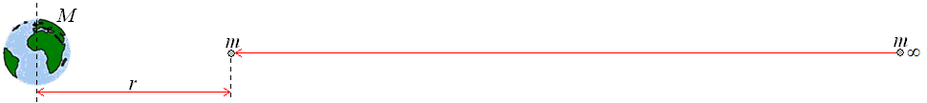
The gravitational potential at a distance r from a mass M is given by: $V=−\frac{\text{GM}}{r}$
The value is negative because the potential at infinity is zero and as we move to the mass we lose potential or energy. Gravitational potential is a scalar quantity.
The gravitational field is attractive so work is done by the field in moving the mass, meaning energy is given out.
Gravitational Potential is measured in Joules per kilogram, J kg⁻¹

Gravitational Potential Energy (Also seen in AS Unit 2)
In Unit 2 we calculated the gravitational potential energy of an object of mass m at a height of h with:
$$E_{P}=\text{mgh}$$
This is only true when the gravitational field strength does not change (or is constant) such as in a uniform field.
For radial fields the gravitational field strength is given by $g=−\frac{\text{GM}}{r^{2}}$
We can use this to help us calculate the gravitational potential energy in a radial field at a height r.
$E_{P}=\text{mgh}$ → $E_{P}=m\frac{\text{GM}}{r^{2}}r$ → $E_{P}=m\frac{\text{GM}}{r}$
(We have dropped the negative sign because energy is a scalar quantity)
If we look at the top equation for gravitational potential we can see that the gravitational potential energy can be calculated using: $E_{P}=\text{mV}$
The work done to move an object from potential V₁ to potential V₂ is given by:
$ΔW=m(V_{2}−V_{1})$ which can be written as $ΔW=mΔV$
Gravitational Potential Energy is measured in Joules, J

Graphs
Here are the graphs of how gravitational field strength and gravitational potential vary with distance from the centre of a mass (eg planet). In both cases R is the radius of the mass (planet).
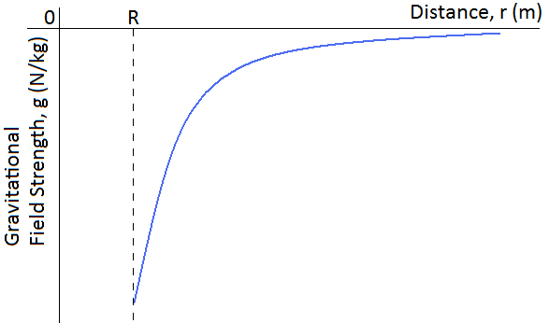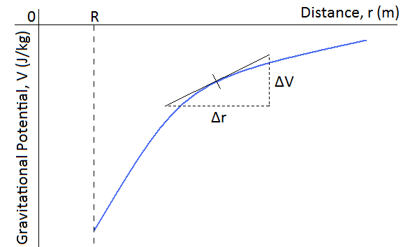
The gradient of the gravitational potential graph gives us the gravitational field strength at that point. To find the gradient at a point on a curve we must draw a tangent to the line then calculate the gradient of the tangent:
$\text{gradient}=\frac{Δy}{Δx}$ → $g=\frac{ΔV}{Δr}$
If we rearrange the equation we can see where we get the top equation for gravitational potential.
$g=\frac{ΔV}{Δr}$ → $gΔr=ΔV$ sub in the equation for g → $−\frac{\text{GM}}{r^{2}}Δr=ΔV$ → $−\frac{\text{GM}}{r^{2}}r=V$ → $−\frac{\text{GM}}{r}=V$
Unit 4 | Orbits and Escape Velocity
Lesson 11
Learning Outcomes | To be able to calculate the orbital speed of a satellite if given the height from the Earth
Learning Outcomes | To be able to calculate the time of orbit of a satellite if given the height from the Earth
Learning Outcomes | To be able to calculate the escape velocity from a planet | N. DWYER

Orbits (Also seen in GCSE Physics 3)
For anything to stay in orbit it requires two things:
*A centripetal force, caused by the gravitational force acting between the object orbiting and the object being orbited
*To be moving at a high speed
We now know equations for calculating the centripetal force of an object moving in a circle of radius r AND for calculating the gravitational force between two masses separated by a distance of r.
Centripetal force at distance r: $F=\text{mv}ω$ or $F=\text{mr}ω^{2}$ or $F=\frac{{\text{mv}}^{2}}{r}$
Gravitational force at distance r: $F=\frac{\text{GMm}}{r^{2}}$
These forces are equal to each other, since it is the force of gravity causing the centripetal force.
From these we can calculate many things about an orbiting object:
The speed needed for a given radius
$\frac{{\text{mv}}^{2}}{r}=\frac{\text{GMm}}{r^{2}}$ → $\frac{v^{2}}{r}=\frac{\text{GM}}{r^{2}}$ → $v^{2}=\frac{\text{GM}}{r}$ → $v=\sqrt{\frac{\text{GM}}{r}}$
The time of orbit for a given radius
$\text{mr}ω^{2}=\frac{\text{GMm}}{r^{2}}$ → $ω^{2}=\frac{\text{GM}}{r^{3}}$ → $(2πf)^{2}=\frac{\text{GM}}{r^{3}}$ → ${\left(\frac{2π}{T}\right)}^{2}=\frac{\text{GM}}{r^{3}}$
→ $\frac{4π^{2}}{T^{2}}=\frac{\text{GM}}{r^{3}}$ → $\frac{T^{2}}{4π^{2}}=\frac{r^{3}}{\text{GM}}$ → $T^{2}=\frac{4π^{2}r^{3}}{\text{GM}}$ → $T=\sqrt{\frac{4π^{2}r^{3}}{\text{GM}}}$

Energy of Orbit
The total energy of a body in orbit is given by the equation:
Total energy = Kinetic energy + Potential energy or $E_{T}=E_{K}+E_{P}$
$E_{T}=\frac{1}{2}{\text{mv}}^{2}−\frac{\text{GMm}}{r}$ → $E_{T}=\frac{1}{2}m{\left(\sqrt{\frac{\text{GM}}{r}}\right)}^{2}−\frac{\text{GMm}}{r}$ → $E_{T}=\frac{1}{2}\frac{\text{GMm}}{r}−\frac{\text{GMm}}{r}$ → $E_{T}=−\frac{1}{2}\frac{\text{GMm}}{r}$

Geostationary Orbits (Also seen in GCSE Physics 3)
Geostationary orbiting satellites orbit around the equator from West to East. They stay above the same point on the equator meaning that the time period is 24 hours or seconds. They are used for communication satellites such as television or mobile phone signals.

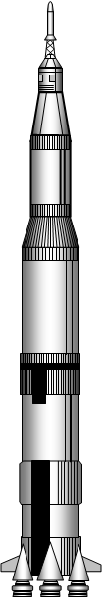
Escape Velocity
For an object to be thrown from the surface of a planet and escape the gravitational field (to infinity) the initial kinetic energy it has at the surface must be equal to the potential energy (work done) to take it from the surface to infinity.
Potential energy: $E_{P}=m\frac{\text{GM}}{R}$ Kinetic energy: $E_{K}=\frac{1}{2}{\text{mv}}^{2}$
$\frac{1}{2}{\text{mv}}^{2}=m\frac{\text{GM}}{R}$ → $\frac{1}{2}v^{2}=\frac{\text{GM}}{R}$ → $v^{2}=\frac{2\text{GM}}{R}$ → $v=\sqrt{\frac{2\text{GM}}{R}}$
For an object to be escape the Earth…..
$v=\sqrt{\frac{2\text{GM}}{R}}$ $v=\sqrt{\frac{2(6\text{.}\text{67}×{\text{10}}^{−\text{11}})(6\text{.}\text{00}×{\text{10}}^{\text{24}})}{(6\text{.}\text{40}×{\text{10}}^{6})}}$ v = 11183 m/s
This calculation is unrealistic. It assumes that all the kinetic energy must be provided instantaneously. We have multistage rockets that provide a continuous thrust.
Unit 4 | Electric Fields
Lesson 12
Learning Outcomes | To be able to calculate the force of gravity between two charges
Learning Outcomes | To be able to explain what electric field strength is
Learning Outcomes | To be able to calculate the electric field strength at a distance r from the centre | N. DWYER

Coulomb’s Law (Electric Force) (Also seen in GCSE Physics 2)
The electrostatic force acts between all charged particles and can be attractive or repulsive. It is the charges themselves that cause the force to exist. The force that acts between two charges, Q₁ and Q₂, whose centres are separated by a distance of r is given by:
$$F∝\frac{Q_{1}Q_{2}}{r^{2}}$$
Like charges Opposite charges Like charges

The proportional constant was found and the equation becomes:
$$F=\frac{1}{4{\text{πε}}_{0}}\frac{Q_{1}Q_{2}}{r^{2}}$$
ε₀ is the Permittivity of Free Space, ε₀ = 8.854 x 10⁻¹² F m⁻¹
When one of the charges is large, Q, the force between it and a test charge, q, whose centres are separated by a distance of r is given by:
$$F=\frac{\text{Qq}}{4{\text{πε}}_{0}r^{2}}$$
If the two charges are positive, (+Q)(+q) = + Qq A positive force means the charges repel.
If the two charges are negative, (–Q)(–q) = + Qq A positive force means the charges repel.
If one is negative and one is positive, (–Q)(+q) = – Qq A negative force means the charges attract.

Electric Fields
An electric field is the area around a charge where any other charge will experience a force. We can model a field with field lines or lines of force.
Radial Fields
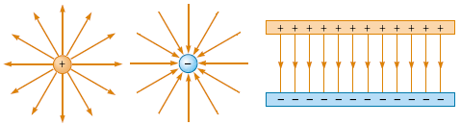
For a positive charge the field lines start at the charge and go out to infinity. For a negative charge the field lines end at the centre of a mass and tail back from infinity. We can see that they become more spread out the further from the charge we go.
Uniform Fields
The field lines are parallel in a uniform field. Between two conducting plates the field lines leave the positive plate and enter the negative plate.

Electric Field Strength, E
We can think of electric field strength as the concentration of the field lines at that point. We can see from the diagrams above that the field strength is constant in a uniform field but drops quickly as we move further out in a radial field.
The electric field strength at a point is a vector quantity and is defined as:
The force per unit charge acting on a small charge placed at that point in the field
We can represent this with the equation: $E=\frac{F}{q}$
If we use our equation for the electric force at a distance r and substitute this in for F we get:
$E=\frac{\text{Qq}}{4{\text{πε}}_{0}r^{2}q}$ which simplifies to: $E=\frac{Q}{4{\text{πε}}_{0}r^{2}}$ (RADIAL FIELDS)
Electric Field Strength is measured in Newtons per Coulomb, N C⁻¹
Unit 4 | Electric Potential
Lesson 13
Learning Outcomes | To be able to explain what electric potential is and be able to calculate it
Learning Outcomes | To know what the field strength is like in a uniform field and how it is linked to electric potential
Learning Outcomes | To be able to sketch graphs of potential and field strength over distance from surface | N. DWYER

Electric Potential, V
The electric potential at a point r from a point charge is defined as:
The work done per unit charge against the field to move a positive point charge from infinity to that point
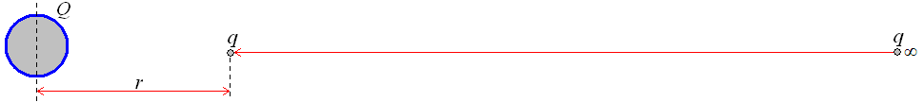
The electric potential at a distance r from a charge Q is given by: $V=\frac{Q}{4{\text{πε}}_{0}r}$
The value will be positive when work is done against the field (when like charges are repelling).
The value will be negative when work is done by the field (when opposite charges attract).
In both cases the potential at infinity is zero. Electric potential is a scalar quantity.
Electric Potential is measured in Joules per Coulomb, J C⁻¹

Electric Potential Difference (Also seen in GCSE Physics 2 and AS Unit 1)
Electric potential is the work done per unit charge which can be written like this:
$$V=\frac{W}{Q}$$
We came across this equation in the QVIRt lesson of Unit 1. We used it to define the potential difference as the energy given to each charge. From what we have just defined we can now update our definition of potential difference. Potential difference is the difference in electric potential between two points in an electric field.
The work done to move a charge from potential V₁ to potential V₂ is given by:
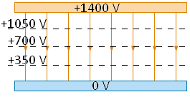
$ΔW=Q(V_{2}−V_{1})$ which can be written as $ΔW=QΔV$

Uniform Fields
In a uniform field like that between two conducting plates the field strength is constant as we have already seen. Now that we understand electric potential we can use an equation for the field strength in a uniform field.
$E=\frac{V}{d}$ Where V is the potential difference between the plates and d is the separation of the plates.
Electric Field Strength can be measured in Volts per metre, V m⁻¹

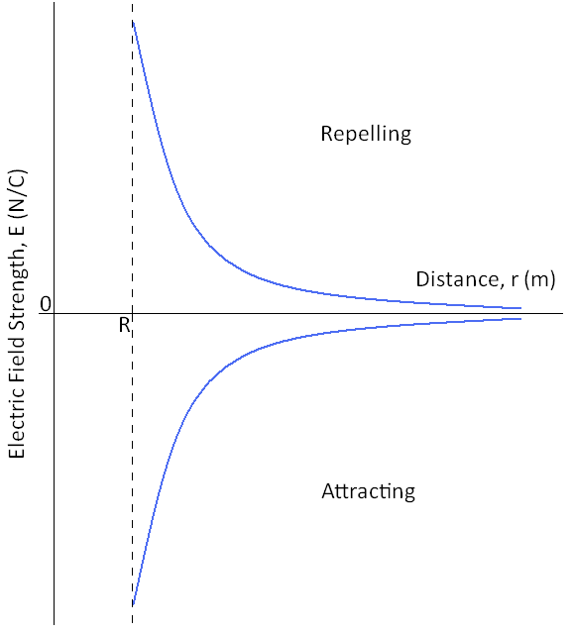
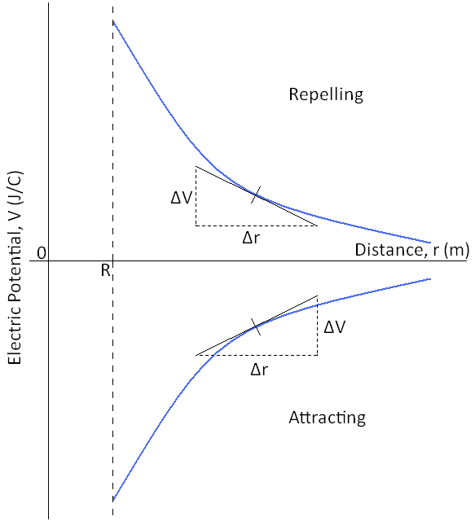
Graphs
Here are the graphs of how electric field strength and electric potential vary with distance from the centre of a charged sphere. In both cases R is the radius of the sphere.

The gradient of the electric potential graph gives us the electric field strength at that point. To find the gradient at a point on a curve we must draw a tangent to the line then calculate the gradient of the tangent:
$\text{gradient}=\frac{Δy}{Δx}$ → $E=\frac{ΔV}{Δr}$
If we rearrange the equation we can see where we get the top equation for electric potential.
$E=\frac{ΔV}{Δr}$ → $EΔr=ΔV$ sub in the equation for E → $\frac{Q}{4{\text{πε}}_{0}r^{2}}Δr=ΔV$ → $\frac{Q}{4{\text{πε}}_{0}r^{2}}r=V$ → $\frac{Q}{4{\text{πε}}_{0}r}=V$
Unit 4 | Fields Comparison
Lesson 14
Learning Outcomes | To be able to describe and explain the motion of a charged particle in an electric field
Learning Outcomes | To be able to state the similarities between gravitational and electric fields
Learning Outcomes | To be able to state the differences between gravitational and electric fields | N. DWYER

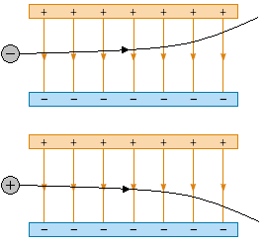
Motion in an Electric Field
A charged particle moving through an electric field will feel a force towards the oppositely charged plate.
We see that the electron moves in a parabola towards the positive plate and the positron moves towards the negative plate.

The field strength is constant so the force is the same at all points in the field and is given by $F=\text{qE}$. The direction of the force depends on the charge of the particle entering the field

Like the projectiles we looked at during AS Unit 2, the vertical velocity is independent from the horizontal velocity.
The acceleration in the vertical plane will be equal to E and it will ‘freefall’ like a mass in a gravitational field.

Comparing Fields
We have seen that the characteristics of gravitational and electric fields have some similarities and differences.
 | Gravitational Fields | Electric Fields
Force is between | Masses | Charges
Constant of proportionality | $$G$$ | $$\frac{1}{4{\text{πε}}_{0}}$$
Equation for force | $$F=−\frac{{\text{Gm}}_{1}m_{2}}{r^{2}}$$  Newton (N)  Vector | $$F=\frac{1}{4{\text{πε}}_{0}}\frac{Q_{1}Q_{2}}{r^{2}}$$  Newtons (N)  Vector
Nature of force | Attractive only | Like charges repel  Different charges attract
Definition of field strength | Force per unit mass | Force per unit charge
Field strength in radial field | $$g=−\frac{\text{GM}}{r^{2}}$$  Newtons per kilogram (N/kg)  Vector | $$E=\frac{Q}{4{\text{πε}}_{0}r^{2}}$$  Newtons per Coulomb (N/C)  Vector
Definition of potential | The work done in bringing a unit mass from infinity to the point in the field | The work done in bringing a unit charge from infinity to the point in the field
Potential | $$V=−\frac{\text{GM}}{r}$$  Joules per kilogram (J/kg)  Scalar | $$V=\frac{Q}{4{\text{πε}}_{0}r}$$  Joules per Coulomb (J/C)  Scalar
Potential at infinity | 0 | 0
Work done moving between points of different potential | $$ΔW=mΔV$$  Joules (J)  Scalar | $$ΔW=QΔV$$  Joules (J)  Scalar
Gradient of potential against distance graph | Field strength | Field strength

Unit 4 | Capacitors
Lesson 15
Learning Outcomes | To be able to calculate capacitance
Learning Outcomes | To be able to explain what happens as a capacitor charges up
Learning Outcomes | To be able to derive the energy stored by a capacitor | N. DWYER

Capacitors
A capacitor is an electronic component that can store electrical charge and then release it.
It is made of two conducting plates separated by an insulator.
The charge that is stored by the capacitor is due to the potential difference across. We can write this as:
Q V or Q = kV
k is a constant specific to the capacitor, this is called the capacitance and is represented by the symbol C
$$Q=\text{CV}$$
Capacitance is measured in Farads, F
Charge is measured in Coulombs, C
We can rearrange the equation into C = Q / V and from this we can see that capacitance is a measure of the charge stored per volt of potential difference. 1 Farad means 1 Coulomb of charge is stored per Volt.

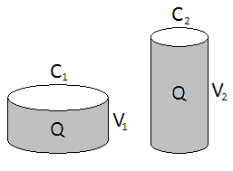
Water Analogy
We can think of the charge stored by a capacitor as the volume of water in a bucket.
The cross-sectional area of the bucket represents the capacitance of the capacitor. We can see that the capacitance of capacitor 1 is higher than the capacitance of capacitor 2.
The height of the water represents the potential difference across the capacitor. We can see that the potential difference across capacitor 2 is higher than the p.d. across capacitor 1. The charge stored by both capacitors is the same.
A capacitor with a lower capacitance can store more charge if the p.d. across it is increased.

Charging and Discharging
When a capacitor is connected to a battery is sends out electrons to one of the plates, this becomes negatively charged. The same amount of electrons move from the second plate and enter the battery, leaving the plate positively charged. The capacitor is now storing a charge or is ‘charged’.

If the charged capacitor is disconnected from the battery and connected to a lamp it will give out the stored charge or will ‘discharge’. The electrons on the negative plate move through the circuit and onto the positive plate. The plates now have no charge on them. The energy stored by the capacitor is transferred to the bulb whilst the electrons move (whilst a current flows).

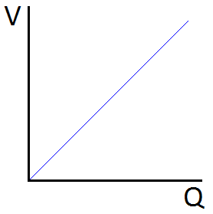
Energy Stored by a Capacitor
The top equation shows us that the charge of a capacitor increases with the potential difference across it. If we plotted p.d. against charge we get a graph that looks like this →

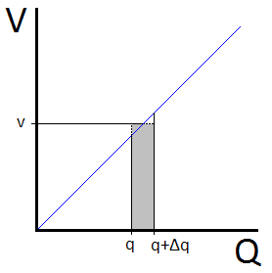
We can derive an equation to find the energy that a capacitor stores by considering the energy transferred during the shaded section on the lower graph.
In this section the charge changes from q to q+Δq when an average p.d. of v is applied across it.
Using E = VQ (see AS Unit 1) the energy stored is E = v Δq.
The total energy is equal to the total of all the little rectangular sections and is given by E = ½ QV. This is also equal to the area under the graph.
We can use the top equation to derive two more equations for the energy stored by a capacitor:
$E=\frac{1}{2}\text{QV}$ $E=\frac{1}{2}{\text{CV}}^{2}$ $E=\frac{1}{2}\frac{Q^{2}}{C}$
Energy is measured in Joules, J
Unit 4 | Charging and Discharging
Lesson 16
Learning Outcomes | To be able to sketch graphs of charge, p.d. and current over time for a charging capacitor
Learning Outcomes | To be able to sketch graphs of charge, p.d. and current over time for a discharging capacitor
Learning Outcomes | To be able to calculate the time constant and state its significance | N. DWYER
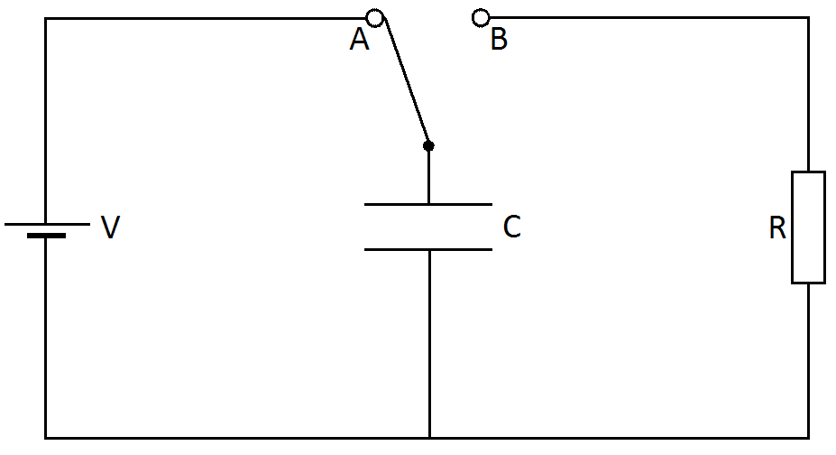
In the diagram to the right a capacitor can be charged by the battery if the switch is moved to position A. It can then be discharged through a resistor by moving the switch to position B.

Charging a Capacitor
When the switch is moved to A the battery sends electrons to the lower plate and takes them from the upper plate. This leaves the lower plate negatively charged and the upper plate positively charged. An electric field is set up between the plates.
Current The current is the flow of electrons through the circuit (see Unit 1). There is a large current initially as electrons move to the lower plate. As time passes and more electrons are on the plate it becomes more difficult to add more due to the electrostatic repulsion of similar charges. When no more electrons move in the circuit the current drops to zero.
Charge The charge stored by the capacitor increases with every electron the moves to the negative plate. The amount of charge increases quickly at the beginning because a large current is flowing. As the current drops the rate at which the charge increases also drops. A maximum charge is reached.
P.D. Since potential difference is proportional to charge, as charge builds up so does p.d. The maximum value of p.d. is reached as is equal to the terminal p.d. of the battery.
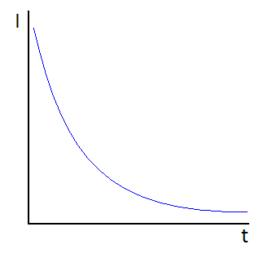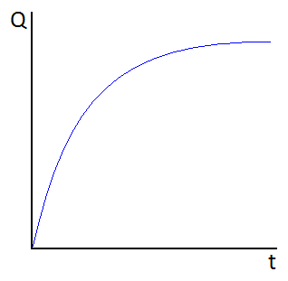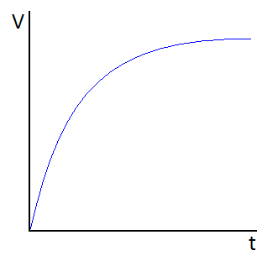
Discharging a Capacitor
When the switch in moved to B the electrons on the negative plate repel each other and move back into the circuit. Eventually both plates lose their charge and the electric field between them disappears.
Current There is initially a large current as the electrons leave the negative plate. As the number of electrons on the negative plate falls so does the size of the repulsive electrostatic force, this makes the current fall at a slower rate. When no more electrons move in the circuit the current drops to zero.
Charge The charge that was stored on the plates now falls with every electron that leaves the negative plate. The charge falls quickly initially and then slows, eventually reaching zero when all the charge has left the plates.
P.D. As the charge falls to zero so does the potential difference across the capacitor.
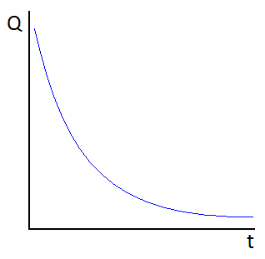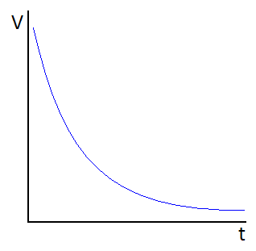
Time Constant, τ
The time it takes for the capacitor to discharge depends on the ‘time constant’.
The time constant is the time it takes for the charge or p.d. of a capacitor to fall to 37% of the initial value. OR
The time constant is the time it takes for the charge or p.d. of a capacitor to fall by 63% of the initial value.
It is given by the equation: $τ=\text{RC}$

If the capacitor has a larger capacitance it means it can hold more charge, this means it will take longer to discharge. If the resistor has a larger resistance it means it is harder to move the electrons around the circuit, this also means it will take longer to discharge.
Unit 4 | Exponential Decay
Lesson 17
Learning Outcomes | To be able to calculate the charge of a discharging capacitor after a time, t
Learning Outcomes | To be able to calculate the potential difference across a discharging capacitor after a time, t
Learning Outcomes | To be able to calculate the current through a discharging capacitor after a time, t | N. DWYER

Finding τ from Graphs
The time constant of a discharging capacitor can be found from a graph of either charge, current or potential difference against time. After one time constant the value will have dropped to 0.37 of the initial value.
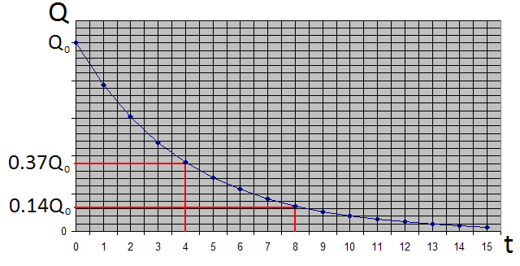
In this case the time constant is 4 seconds.

Quantitative Treatment
We could use the graph above to find the charge on the capacitor after a time, t. We could also use it to find the time it takes for the charge to fall to a value of Q.
This requires the graph to be drawn very accurately and values need to be taken from it very carefully.
Instead of doing this we can use the following equation to calculate the charge, Q after a time, t.
$$Q=Q_{0}e^{{−t}/{\text{RC}}}$$
t is the time that has elapsed since discharge began
Q is the remaining charge
Q₀ is the initial (or starting) charge
RC is the time constant, also equal to the resistance multiplied by the capacitance.
Time is measured in seconds, s
When the time elapsed is equal to the time constant the charge should have fallen to 37% of the initial value.
$Q=Q_{0}e^{{−t}/{\text{RC}}}$ → $Q=Q_{0}e^{{−\text{RC}}/{\text{RC}}}$ → $Q=Q_{0}e^{−1}$ (but e⁻¹ = 0.37) → $Q=Q_{0}0\text{.}\text{37}$
When the time elapsed is equal to twice the time constant the charge should have fallen to 37% of 37% of the initial value.
$Q=Q_{0}e^{{−t}/{\text{RC}}}$ → $Q=Q_{0}e^{−2{\text{RC}}/{\text{RC}}}$ → $Q=Q_{0}e^{−2}$ (but e⁻² = 0.37 x 0.37) → $Q=Q_{0}0\text{.}\text{14}$

Similar equations can be established for the current flowing through and the potential difference across the capacitor after time, t:
$Q=Q_{0}e^{{−t}/{\text{RC}}}$ $I=I_{0}e^{{−t}/{\text{RC}}}$ $V=V_{0}e^{{−t}/{\text{RC}}}$

Rearranging
The equations above can be rearranged to make t the subject. We will use the equation for charge:
$Q=Q_{0}e^{{−t}/{\text{RC}}}$ → $\frac{Q}{Q_{0}}=e^{{−t}/{\text{RC}}}$ → $\text{ln}\left(\frac{Q}{Q_{0}}\right)=−t\text{RC}$ → $\text{ln}\left(\frac{Q}{Q_{0}}\right)\text{RC}=−t$ → $−\text{ln}\left(\frac{Q}{Q_{0}}\right)\text{RC}=t$
They can also be rearranged to make RC (time constant) the subject:
$Q=Q_{0}e^{{−t}/{\text{RC}}}$ → $\frac{Q}{Q_{0}}=e^{{−t}/{\text{RC}}}$ → $\text{ln}\left(\frac{Q}{Q_{0}}\right)=−t\text{RC}$ → $\text{RC}=−t\text{ln}\left(\frac{Q}{Q_{0}}\right)$
Unit 4 | Force on a Current Carrying Wire
Lesson 18
Learning Outcomes | To be able to explain why a wire with a current flowing through it will experience a force
Learning Outcomes | To be able to calculate the size of the force on the wire
Learning Outcomes | To be able to state the direction of the force on the wire | N. DWYER

We will be looking at the force a current carrying wire experiences when it is in a magnetic field.
Before we look into the size and direction of the force we need to establish some basics.

Conventional Current
We know that the current flowing in a circuit is due to the negative electrons flowing from the negative terminal of a battery to the positive terminal.
Negative to Positive is the flow of electrons
Before the discovery of the electron scientist thought that the current flowed from the positive terminal to the negative one. By the time the electron was discovered many laws had been established to explain the world around them using current as flowing from positive to negative.
Positive to Negative is the Conventional Current

Magnetic Field Lines
We are familiar with the shape of a magnetic field around a bar magnet. Magnetic field lines leave the North Pole of the magnet and enter the South Pole. The poles of a magnet are stronger than the side because there are more field lines in the same area of space.
Magnetic field lines go from North to South

A 3D Problem
We will be looking at movement, fields and currents in 3D but our page is only 2D. To solve this problem we will use the following notation: A dot means coming out of the page and a cross means going into the page. Imagine an arrow fired from a bow, pointy end means it’s coming towards you, cross means its moving away.
out of the page, into the page

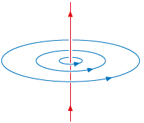
Current Carrying Wires
When a current flows through a straight piece of wire it creates a circular magnetic field. The Right Hand Grip Rule shows us the direction of the magnetic field. If we use our right hand and do a thumbs up the thumb is the direction of the conventional current and the fingers point the direction of the field lines.
Right hand thumbs up

Force on a Current Carrying Wire
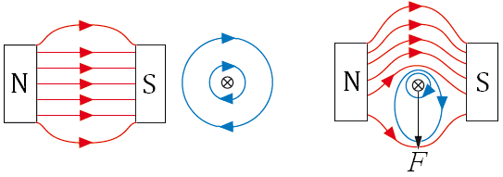
When a wire is placed between a North and South Pole (in a magnetic field), nothing happens.
When a (conventional) current flows through the wire it experiences a force due to the magnetic fields of the magnet and the wire. If we look at the diagram we can see that the magnetic field lines above are more compact than below. This forces the wire downwards.
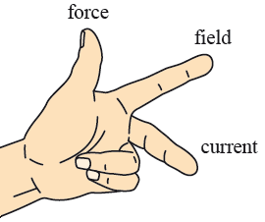

Fleming’s Left Hand Rule
This rule links the directions of the force, magnetic field and conventional current which are all at right angles to each other. Your first finger points from North to South, your middle finger points from positive to negative and your thumb points in the direction of the force.

Size of the Force
The size of the force on a wire of length l, carrying a current I placed in a magnetic field of magnetic flux density B is given by the equation: $F=\text{BIl}$
Here the wire is at 90° to the magnetic field lines.
When the wire is at an angle of θ with the magnetic field the force is given by: $F=\text{BIl}\text{sin}θ$
If we rearrange the equation to$B=\frac{F}{\text{Il}}$we see that 1 Tesla is the magnetic flux density (field strength) that causes a 1 Newton force to act on 1 metre of wire carrying 1 Amp of current.
Magnetic Flux Density is measured in Tesla, T
This equation looks very familiar if we compare it to the force in a gravitational and electric field.
$F=m\text{.}g$ $F=q\text{.}E$ $F=\text{Il}\text{.}B$
Unit 4 | Force on a Charged Particle
Lesson 19
Learning Outcomes | To be able to calculate the size and direction of the force on a charged particle in a magnetic field
Learning Outcomes | To be able to describe the motion of a charged particle in a magnetic field
Learning Outcomes | To be able to describe the main features of a cyclotron and explain how it works | N. DWYER

Force on Charged Particle
From our equation for the force a magnetic field will exert on a wire we can derive a equation for the force it will exert on a single charged particle.
Start with $F=\text{BIl}$. In Unit 1 we defined the current as $I=\frac{Q}{t}$ so we can sub this in to become $F=B\frac{Q}{t}l$
We can rewrite this equation $F=\text{BQ}\frac{l}{t}$and use $v=\frac{l}{t}$ from Unit 2 to arrive at the equation: $F=\text{BQv}$
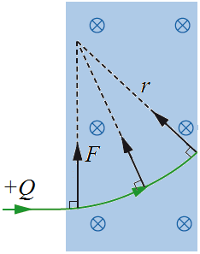

Moving in a Circle
If a charged particle enters a magnetic field it will feel a force. We now know the size of the force (given by equation above) and direction of the force (given by Fleming’s Left Hand Rule).
If we use the left hand rule in the diagram to the right we can see that the force is always at right angles to the velocity. First finger points into the page, middle finger points along the line and our thumb points upwards.
While the particle is in the magnetic field it will move in a circle.
Radius of the circle
We can calculate the radius a charged particle will move in by using our equation for the force on a charged particle in a magnetic field and a centripetal force equation.
$F=\text{BQv}$ and $F=\frac{{\text{mv}}^{2}}{r}$ are equal to each other so we can write $\text{BQv}=\frac{{\text{mv}}^{2}}{r}$ → $r=\frac{{\text{mv}}^{2}}{\text{BQv}}$ → $r=\frac{\text{mv}}{\text{BQ}}$
Time for a complete circle
We can also calculate the time it takes for the charged particle to move in one complete circle.
Starting at$F=\text{mv}ω$ we can use $ω=2πf$to make the equation become $F=\text{mv}2πf$ and then $F=\frac{\text{mv}2π}{T}$
The centripetal force is due to the magnetic force on the charged particle so we can put these equal to each other. $\text{BQv}=\frac{\text{mv}2π}{T}$ cancel the v to become $\text{BQ}=\frac{m2π}{T}$ which rearranges to: $T=\frac{m2π}{\text{BQ}}$
So the time it takes to complete a full circle does not depend on the velocity.

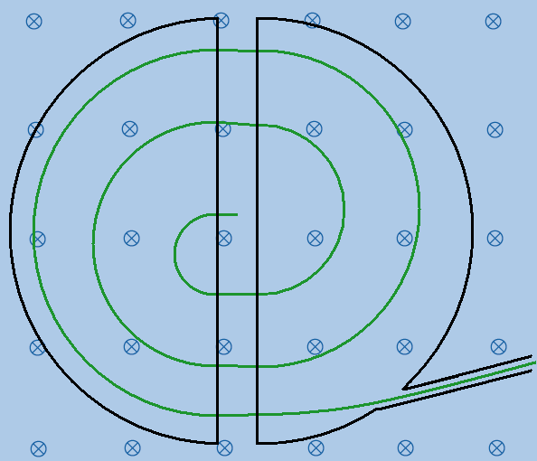
The Cyclotron
A cyclotron is a particle accelerator. It consists of two hollow D-shaped electrodes (called ‘dees’) that are attached to an alternating p.d. supply. The dees are placed in vacuum chamber and a magnetic field which acts at right angles to them.
A particle will move in a circle because of the magnetic field.
When it reaches the gap between the dees the alternating supply has made the other dee have the opposite charge to the particle. This causes the particle to accelerate across the gap and enter the second dee. This continues to happen until the particle is moving at the required speed. At this point it leaves the cyclotron.

The Mass Spectrometer
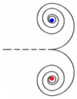
A mass spectrometer is used to analyse the types of atom that are in a sample. The atoms are given a charge, accelerated and sent into a magnetic field. If we look at the radius equation above we can see that atoms travelling at the same speed in the same magnetic field given the same charge will be deflected based on their mass. Heavy atoms will move in bigger circles than lighter ones.

Pair Production
If we think back to Unit 1 we saw this phenomenon in action. Pair production is when a photon of energy is converted into a particle and an antiparticle, such as an electron and a positron. If this happens in a magnetic field the electron will move in a circle in one direction and the positron will move in a circle in the other direction.
Unit 4 | Magnetic Flux and Flux Linkage
Lesson 20
Learning Outcomes | To be able to calculate and explain the magnetic flux through a coil of wire
Learning Outcomes | To be able to calculate the magnetic flux linkage of a coil of wire
Learning Outcomes | To be able to calculate the magnetic flux linkage of a rotating coil | N. DWYER

Magnetic Flux, φ
Magnetic flux is a measure of how many magnetic field lines are passing through an area of A m².
The magnetic flux through an area A in a magnetic field of flux density B is given by: $φ=\text{BA}$
This is when B is perpendicular to A, so the normal to the area is in the same direction as the field lines.
Magnetic Flux is measured in Webers, Wb
The more field pass through area A, the greater the concentration and the stronger magnetic field.
This is why a magnet is strongest at its poles; there is a high concentration of field lines.
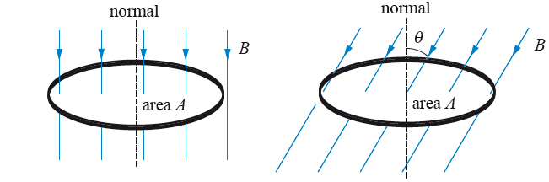
We can see that the amount of flux flowing through a loop of wire depends on the angle it makes with the field lines. The amount of flux passing through the loop is given by: $φ=\text{BA}\text{cos}θ$
θ is the angle that the normal to the loop makes with the field lines.

Magnetic Flux Density
We can now see why B is called the magnetic flux density. If we rearrange the top equation for B we get:
$B=\frac{φ}{A}$ So B is a measure of how many flux lines (field lines) passes through each unit area (per m²).
A flux density of 1 Tesla is when an area of 1 metre squared has a flux of 1 Weber.

Flux Linkage
We now know that the amount of flux through one loop of wire is: $φ=\text{BA}$
If we have a coil of wire made up of N loops of wire the total flux is given by: $Nφ=\text{BAN}$
The total amount of flux, $Nφ$, is called the Magnetic Flux Linkage; this is because we consider each loop of wire to be linked with a certain amount of magnetic flux.
Sometimes flux linkage is represented by $Φ$, so $Φ=Nφ$ which makes our equation for flux linkage $Φ=\text{BAN}$
Flux Linkage is measured in Webers, Wb

Rotating Coil in a Magnetic Field
If we have a rectangle of wire that has an area of A and we place it in a magnetic field of flux density B, we have seen that the amount of flux flowing through the wire depends on the angle between it and the flux lines.
The flux linkage at an angle θ from the perpendicular to the magnetic field is given by: $Nφ=\text{BAN}\text{cos}θ$
From our lessons on circular motion we established that the angular speed is given by $ω=\frac{θ}{t}$ which can be rearranged to $θ=ωt$and substituted into the equation above to transform it into: $Nφ=\text{BAN}\text{cos}ωt$
When t = 0 the wire is perpendicular to the field so there is a maximum amount of flux.
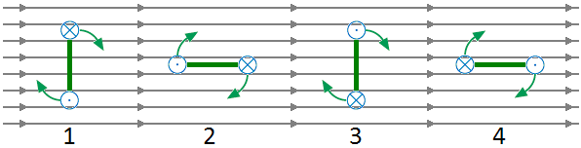
At 1 the flux linkage is a maximum in one direction. There is the lowest rate of change at this point.
At 2 the flux linkage is zero. There is the biggest rate of change at this point
At 3 the flux linkage is maximum but in the opposite direction. The lowest rate of change occurs here too.
At 4 the flux linkage is zero. There is the biggest rate of change at the point too but in the opposite direction.
Next lesson we will be looking at inducing an e.m.f. using a wire and a magnetic field. The size of the e.m.f. depends on the rate of change of flux linkage.
Unit 4 | Electromagnetic Induction
Lesson 21
Learning Outcomes | To know how emf and current are induced
Learning Outcomes | To know Faraday’s Law and be able to use it to describe the induced emf
Learning Outcomes | To know Lenz’s Law and be able to use it to describe the induced emf | N. DWYER

Making Electricity (Also seen at GCSE Physics 3)
An e.m.f. can be induced across the ends of a conducting wire in two ways:
1) Move the wire through a magnetic field or 2) Move a magnet through a coil of the wire
In both cases magnetic field lines and wires are cutting through each other. We say that the wire is cutting through the magnetic field lines (although it is fair to say that the field lines are cutting through the wire).
If the conductor is part of a complete circuit a current will be induced through it as well as an e.m.f. across it.
There are two laws that describe the induced e.m.f...

Faraday’s Law – Size of induced e.m.f.
The magnitude of the e.m.f. induced in a conductor equals the rate of change of flux linkages or the rate at which the conductor cuts a magnetic flux.
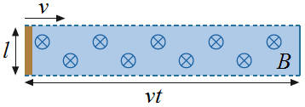
Straight Wire
Imagine a straight piece of wire of length l is moved through a magnetic field at a velocity v. If the wire is moving at right angles to the field lines an e.m.f. is induced (because field lines are being cut).
The size of the e.m.f. is given by the equation:
$ε=\frac{NΔφ}{Δt}$
For one loop of wire $ε=\frac{Δφ}{Δt}$ and the flux is given by $φ=\text{BA}$ which are combine to become $ε=\frac{Δ\text{BA}}{Δt}$
B is constant so $ε=\frac{BΔA}{Δt}$. ΔA is the area the wire cuts through in a time t and is given by$A=l\text{.}\text{vt}$ so we get: $ε=\frac{BΔl\text{.}\text{vt}}{Δt}$ The length of the wire and velocity are constant so it becomes$ε=\frac{\text{Blv}Δt}{Δt}$ which cancels to: $ε=\text{Blv}$
Rotating Coil of Wire
If we have a coil of wire with N turns, each of which has an area of A and placed it a magnetic field of flux density B nothing would happen. If it was rotated with an angular speed of ω it would cut through the magnetic field lines and an e.m.f. would be induced. The size of the e.m.f. is given by:
Since $ε=N\frac{Δφ}{Δt}$ and $φ=\text{BA}\text{cos}ωt$ we get $ε=N\frac{Δ(\text{BA}\text{cos}ωt)}{Δt}$ and if we differentiate it: $ε=\text{BAN}ω\text{sin}ωt$
This is why the Mains supply is alternating; the rotating coil cuts the field lines in one direction on the way up and the other direction on the way down.

Lenz’s Law – Direction of induced e.m.f.
The direction of the e.m.f. induced in a conductor is such that it opposes the change producing it.
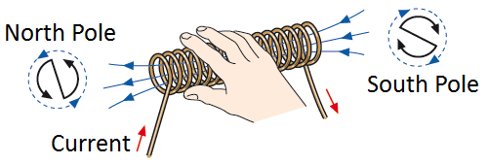
Solenoid (Right Hand Grip Rule)
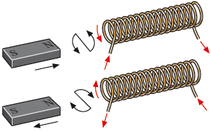
A solenoid with a current flowing through it produces a magnetic field like that of a bar magnet. We can work out which end is the North Pole and which is the South by using the Right Hand Grip Rule from our force on a wire lesson. If our fingers follow the direction of the current through the coils our thumb points out of the North Pole.
*When we push the North Pole of a magnet the induced current in the solenoid flows to make a North Pole to repel the magnet.
*When we pull the North Pole out of the solenoid the induced current flows to make a South Pole to attract the magnet.
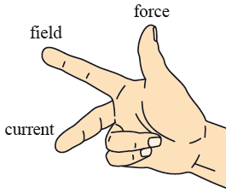
Fleming’s Right Hand Rule
If we are just moving a straight wire through a uniform magnetic field the direction of the induced current can be worked out using Fleming’s Right Hand Rule.
Your first finger points in the direction of the field from North to South, your thumb points in the direction the wire is moved and your middle finger points in the direction of the conventional current.
Unit 4 | Transformers
Lesson 22
Learning Outcomes | To be able to describe a transformer and calculate the voltage and current in the secondary coil
Learning Outcomes | To be able to calculate the efficiency of a transformer and explain why they are used
Learning Outcomes | To be able to state the causes of inefficiency in transformers | N. DWYER

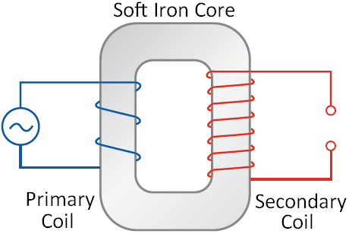
Transformers (Also seen at GCSE Physics 3)
A transformer is a device used to change the voltage/current of a circuit using electromagnetic induction. It consists of a soft iron core wrapped on both side with wire. The first coil of wire is called the primary coil and the other coil of wire is called the secondary coil.
A current doesn’t flow from one coil of wire to the other.
How They Work
A current flows through the primary coil which creates a magnetic field.
As this field is established the field lines cut through the turns of wire on the secondary coil. This induces an e.m.f. (voltage) and a current in the second coil.
Since the supply to the primary coil is constantly changing direction the magnetic field is constantly changing direction. This means the secondary coil also has an alternating e.m.f. and current.
An iron core is used because it is easily magnetised and demagnetised and conducts the magnetic field.

Transforming Voltage and Current (Also seen at GCSE Physics 3)
There are two types of transformers:
Step Up
The voltage in the secondary coil is larger than the voltage in the primary coil.
The current in the secondary coil is smaller than the current in the primary coil.
There will be more turns of wire on the secondary coil meaning more flux linkage
Step Down
The voltage in the secondary coil is smaller than the voltage in the primary coil.
The current in the secondary coil is larger that the current in the primary coil.
There will be fewer turns of wire on the secondary coil meaning less flux linkage

In both cases the voltage and current (V_{P} and I_{P}) in the primary coil of N_{P} turns is linked to the voltage and current (V_{S} and I_{S}) in the secondary coil of N_{S} turns by the following equation:
$$\frac{N_{S}}{N_{P}}=\frac{V_{S}}{V_{P}}=\frac{I_{P}}{I_{S}}$$

The National Grid (Also seen at GCSE Physics 1)
The National Grid is a system of transformers that increases the voltage (reducing the current) of an alternating electrical supply as it leaves the power station. Thick cables held above the ground by pylons carry the supply to our neighbourhood. A second series of transformers lowers the voltage to a safe level and increases the current to be used in our homes.
Why Bother?
Energy is lost in the transmission of electricity. The electrons flowing in the wire are constantly colliding with the positive ions of the metal that the wire is made from. If we increase the voltage of a supply this lowers the current. Lowering the current reduces the number of collisions happening per second hence reducing the amount of energy lost in reaching our homes.
The cables that carry the current have a larger cross sectional area, this lowers the resistance and energy lost.

Efficiency of a Transformer
The efficiency of a transformer can be calculated using the following equation:
Efficiency $=\frac{I_{S}V_{S}}{I_{P}V_{P}}$
The efficiency of a transformer can be increased by:
*Using low resistance windings to reduce the power wasted due to the heating effect of the current.
*Use a laminated core which consists of layers of iron separated by layers of insulation. This reduces heating in the iron core and currents being induced in the core itself (referred to as eddy currents).

